Free support and resources for home
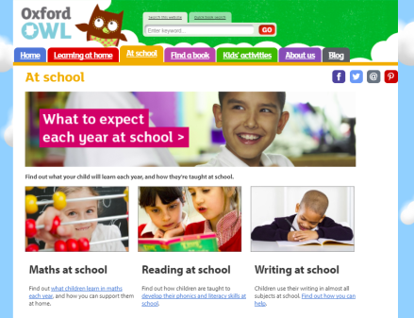
For parents …
As well as support and resources for schools, Oxford Owl has a dedicated site for parents and carers. The resources are free and fully support the fantastic work you do in schools.

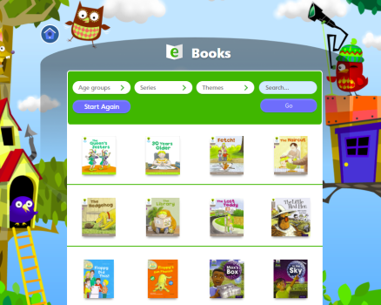
For children …
Oxford Owl also has a dedicated pupil area with full access to the free eBook library. If you haven’t already done so, you can set up a simple login that will allow all your class to access the eBooks at school and at home. Find out more at in the Help section on Oxford Owl for School.

Recommending to parents and carers …
To help parents and carers access Oxford Owl for Home, we have put together information that you can send home in whatever format you choose. This includes …
- Oxford Owl for Home
  - Sample email
  - Sample letter
  - Sample newsletter item
  - Sample social media snippet
  - Sample website text
2. Oxford Owl Class Login
  - Sample email
  - Sample letter
  - Sample sticker template

1a. Oxford Owl for Home: Sample email

Subject line: [NAME OF SCHOOL]: Find FREE support on Oxford Owl
------------------------------------------------------------------------------
Dear Parent/Carer,
At [NAME OF SCHOOL] we have been looking at how we can help you to support your child’s learning at home. We realise it helps to know exactly what topics we’re covering at school and how your child is being taught. Although we make every effort to keep you informed, it is helpful for you to have somewhere to go to find out more and to get additional support.
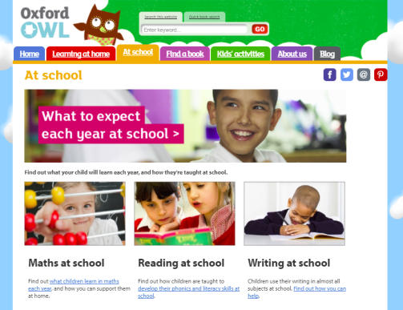
We use Oxford Owl in school and think you would find the dedicated parent/carer pages really useful. Oxford Owl for Home includes expert advice, top tips, activity ideas and eBooks – all for free.
If you would like to take a look, simply go to www.oxfordowl.co.uk and click on ‘For Home’.

Yours sincerely,
[HEADTEACHER NAME]

1b. Oxford Owl for Home: Sample letter

Dear Parent/Carer,

Supporting your child’s learning at home

At [NAME OF SCHOOL] we have been looking at how we can help you to support your child’s learning at home. We realise it helps to know exactly what topics we’re covering at school and how your child is being taught. Although we make every effort to keep you informed, it is helpful for you to have somewhere to go to find out more and to get additional support.
We use Oxford Owl in school and think you would find the dedicated parent/carer pages really useful. Oxford Owl for Home includes expert advice, top tips, activity ideas and eBooks – all for free.
If you would like to take a look, simply go to www.oxfordowl.co.uk and click on ‘For Home’.

Yours sincerely,
[HEADTEACHER NAME]

1c. Oxford Owl for Home: Sample newsletter item
Supporting your child’s learning at home

At [NAME OF SCHOOL] we have been looking at how we can help you to support your child’s learning at home.
We use Oxford Owl in school and think you would find the dedicated parent/carer pages really useful. Oxford Owl for Home includes expert advice, top tips, activity ideas and eBooks – all for free.
If you would like to take a look, simply go to www.oxfordowl.co.uk and click on ‘For Home’.

1d. Oxford Owl for Home: Sample social media snippet
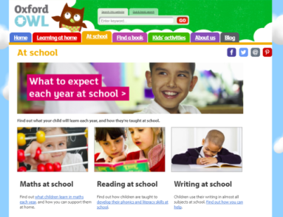
Supporting your child’s learning at home
Are you a parent/carer looking for additional support? Oxford Owl for Home includes expert advice, top tips, activity ideas and eBooks – all for free. To find out more, simply go to www.oxfordowl.co.uk and click on ‘For Home’.

1e. Oxford Owl for Home: Sample website text
Supporting your child’s learning at home
Supporting your child’s learning at home is really important. We realise it is helpful for you to have somewhere to go to find out more and to get additional support.
Oxford Owl for Home has dedicated support for parents and carers that includes expert advice, top tips, activity ideas and eBooks – all for free.
To find out more, simply go to www.oxfordowl.co.uk and click on ‘For Home’.

2a. Oxford Owl Class Login: Sample email

Subject line: [NAME OF SCHOOL]: Login for free eBook Library
------------------------------------------------------------------------------
Dear Parent/Carer,
At [NAME OF SCHOOL] reading is an incredibly important part of our curriculum. We want to support each and every child to develop as independent and engaged readers who read widely and for pleasure.
As part of this, we have created a simple login for [INSERT CLASS NAME] so that you can access a collection of free eBooks to support reading at home.
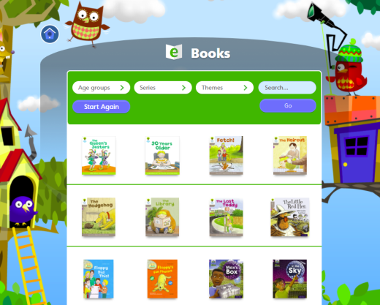
- Simply go to www.oxfordowl.co.uk
- Click on ‘My class login’
- Type in …
My class name:
[INSERT CLASS LOGIN NAME]
My class password:
[INSERT CLASS PASSWORD]

You can browse the books on the bookshelf or if you are looking for a specific book, type the book title into the Search and press Go.

Yours sincerely,
[HEADTEACHER NAME]

2a. Oxford Owl Class Login: Sample letter

Dear Parent/Carer,

At [NAME OF SCHOOL] reading is an incredibly important part of our curriculum. We want to support each and every child to develop as independent and engaged readers who read widely and for pleasure.
As part of this, we have created a simple login for [INSERT CLASS NAME] so that you can access a collection of free eBooks to support reading at home.
- Simply go to www.oxfordowl.co.uk
- Click on ‘My class login’
- Type in …
My class name:
[INSERT CLASS LOGIN NAME]
My class password:
[INSERT CLASS PASSWORD]

You can browse the books on the bookshelf or if you are looking for a specific book, type the book title into the Search and press Go.

Yours sincerely,
[HEADTEACHER NAME]

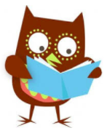  www.oxfordowl.co.uk  eBook title:  ………………………………….…………………. | www.oxfordowl.co.uk  eBook title:  ………………………………….………………….
www.oxfordowl.co.uk  eBook title:  ………………………………….…………………. | www.oxfordowl.co.uk  eBook title:  ………………………………….………………….
www.oxfordowl.co.uk  eBook title:  ………………………………….…………………. | www.oxfordowl.co.uk  eBook title:  ………………………………….………………….
www.oxfordowl.co.uk  eBook title:  ………………………………….…………………. | www.oxfordowl.co.uk  eBook title:  ………………………………….………………….
www.oxfordowl.co.uk  eBook title:  ………………………………….…………………. | www.oxfordowl.co.uk  eBook title:  ………………………………….………………….
www.oxfordowl.co.uk  eBook title:  ………………………………….…………………. | www.oxfordowl.co.uk  eBook title:  ………………………………….………………….
www.oxfordowl.co.uk  eBook title:  ………………………………….…………………. | www.oxfordowl.co.uk  eBook title:  ………………………………….………………….

