Free support and resources for home

1b. Oxford Owl for Home: Email to parents

Subject line: [NAME OF SCHOOL]: Find FREE support on Oxford Owl
------------------------------------------------------------------------------
Dear Parent/Carer,

Helping your child to learn

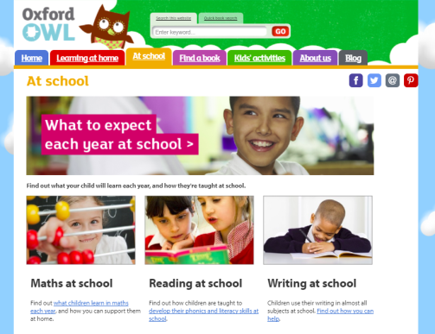
At school, we use resources from Oxford Owl, and thought you might be interested in their website for parents and carers.
On the website, you’ll find lots of information about the national curriculum and what to expect each year at school, videos to help with homework and tips on supporting your child at home, along with free eBooks and activity sheets –all in line with how we teach your child at school.
If you’d like to find out more, visit www.oxfordowl.co.uk/home, follow them on Facebook at www.facebook.com/oxfordowl or subscribe to the YouTube Channel at www.youtube.com/OxfordOwlHome.

Yours sincerely,
[HEADTEACHER NAME]

